**HTML TABLE**

A table is an arrangement of data in rows and columns. you may use a table to organize the data.

**Tables Tags:**

Table tag is used to create a table in html document.

**Tr tag:**  <tr>

It is used to define row of html table.

**Th tag:**  <th>

It defines the header cell in a table. By default it set the content with bold and center property.

**Td tag:**  <td>

It defines the standard cell in html document. <td>

**rowspan and colspan:** < th rowspan=2 colspan=2>

Sometimes it makes sense for a cell to span multiple columns or multiple rows.

This might be used for a header cell that titles a group of columns, or a side-bar that groups rows of entries.

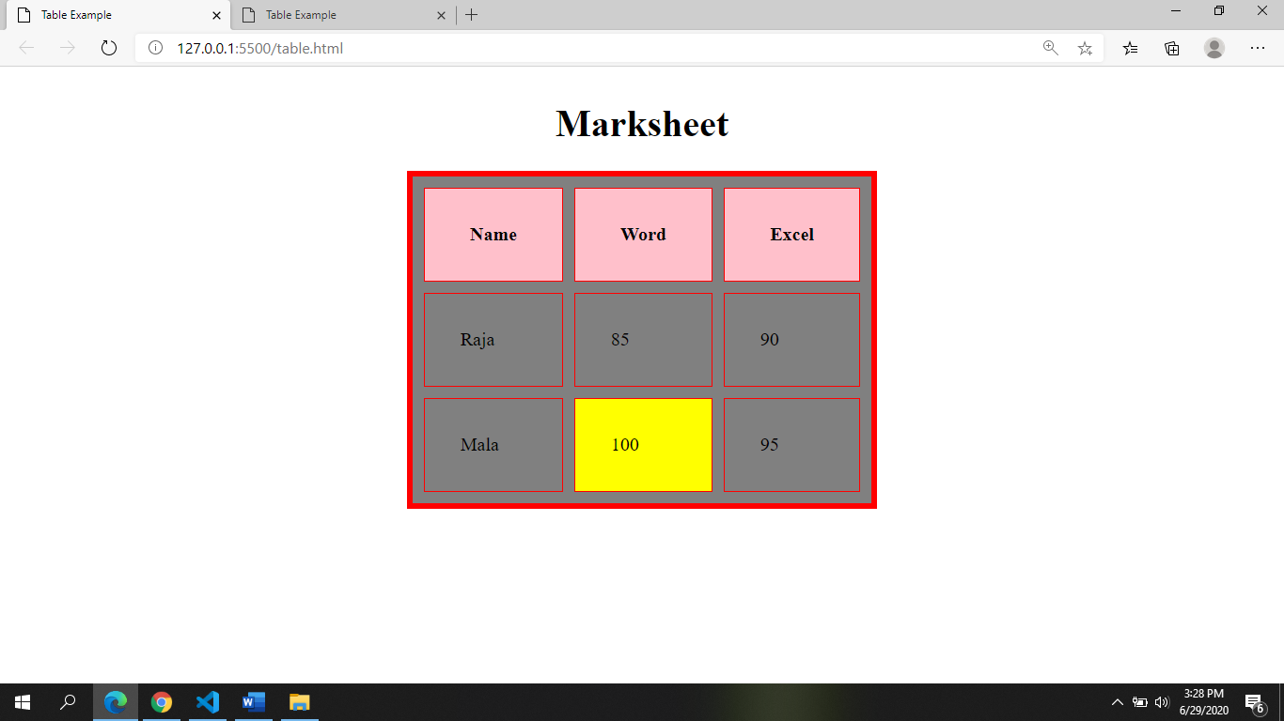

Caption

Table head<th>

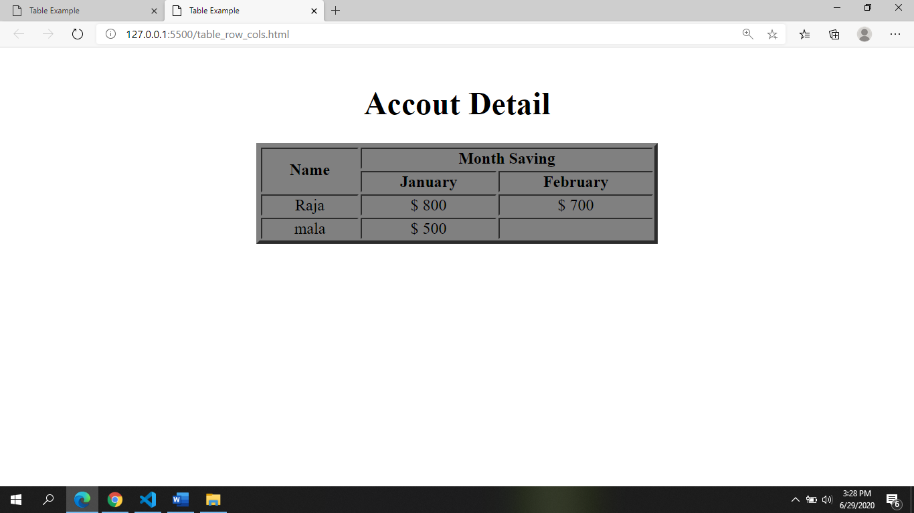

height

&nbsp;

rowspan

colspan

cellspacing

cellpadding

Table row<tr>

Table data<td>

border

width